**Data Driven Testing**

1. What is Data driven testing?

Read the data from external recourse & run the test scripts is called Data driven testing (parameterization)

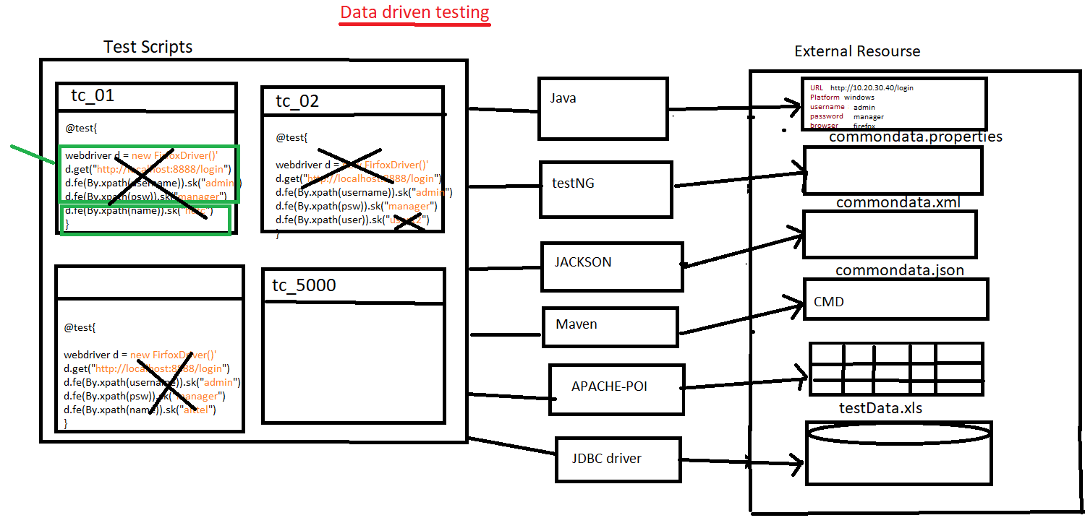

1. Why Data Driven testing?

As per the rule of the automation data shouldn’t not hardcoded because data modification & maintenance is tedious job when you want to run the test with different data, instead we should get the data from external resource like xlsx, properties file, database, XML, JSON, command

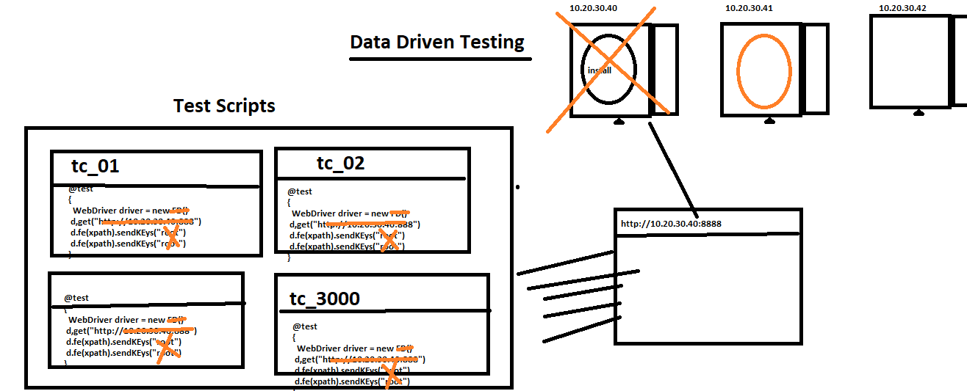

1. What is Advantages of Data driven testing
2. Maintenance of the test data is easy
3. Modification of the test data in external recourse is easy
4. Cross browser testing is easy (means change the browser in property File)
5. Running test scripts in different Environment is easy
6. Running test scripts in different credentials is easy
7. We can create the test data prior the Suite execution (we can also get the data from test Data team)
8. Rerunning test Script with multiple time is easy
9. **How to read data from properties File?**

* Get the java Object of the Physical file using “FileInputSteam”.
* Create an Object of “Properties” class & load all the keys.
* Read the data using getProperty(“Key”).

**Note**: properties file is light weight & faster in execution compare to Excel.

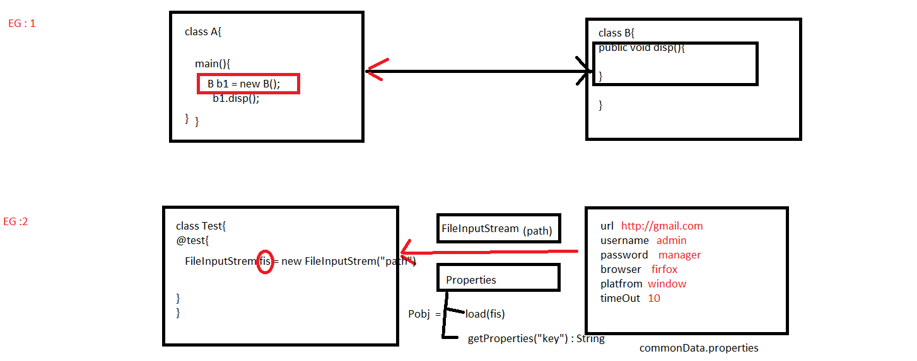

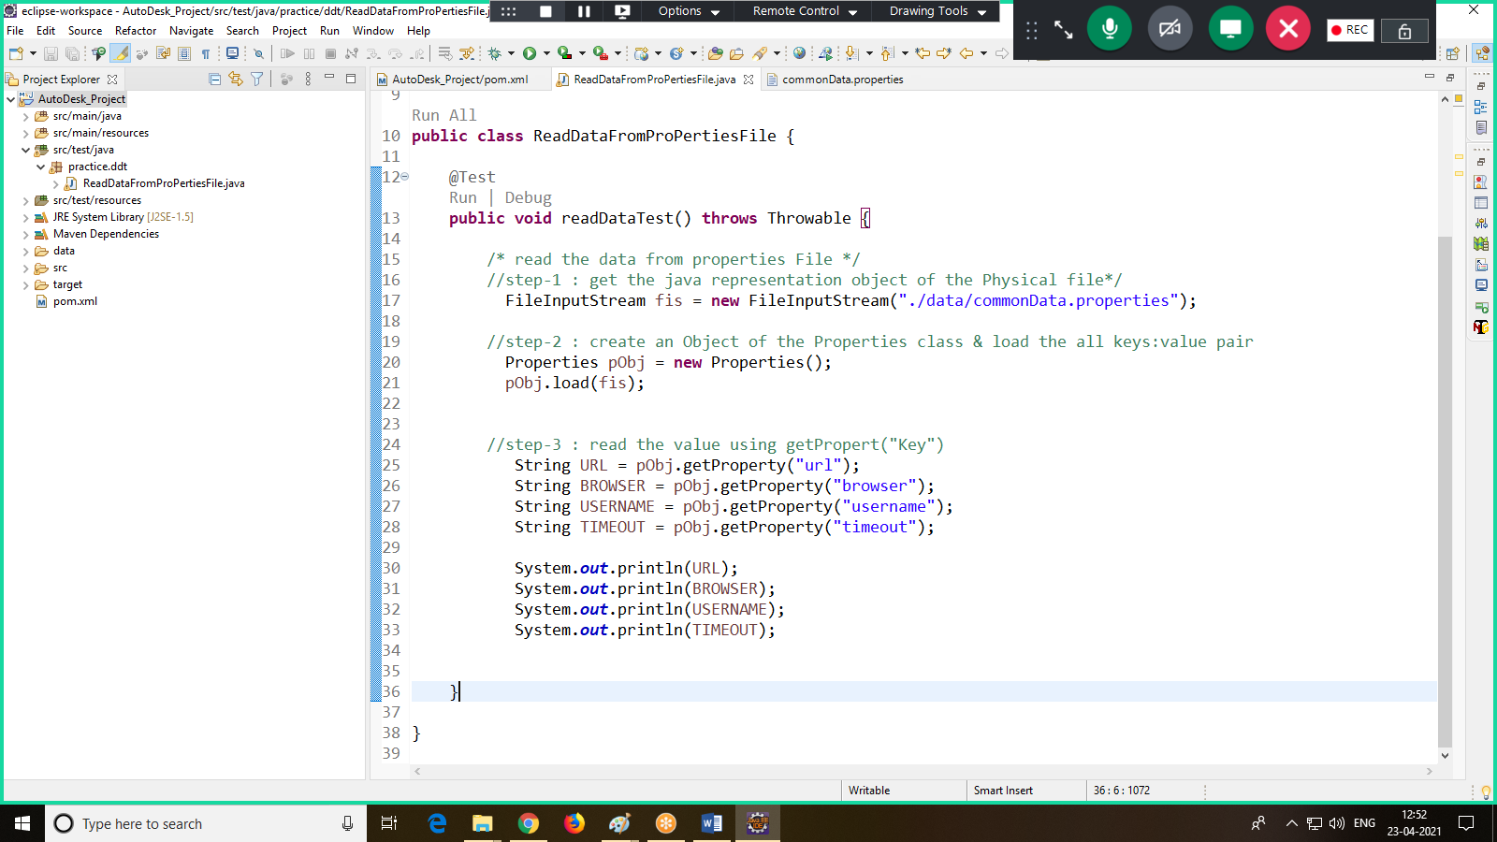

1. **How to read data from testing.xml**

Step1: write common data in XML file using <parameter>, data will be in the form of name: value pair

Step 2: using XMLTest class, we can read the data from testing.xml file

Step 3: make sure we always run the test via testing.xml file only

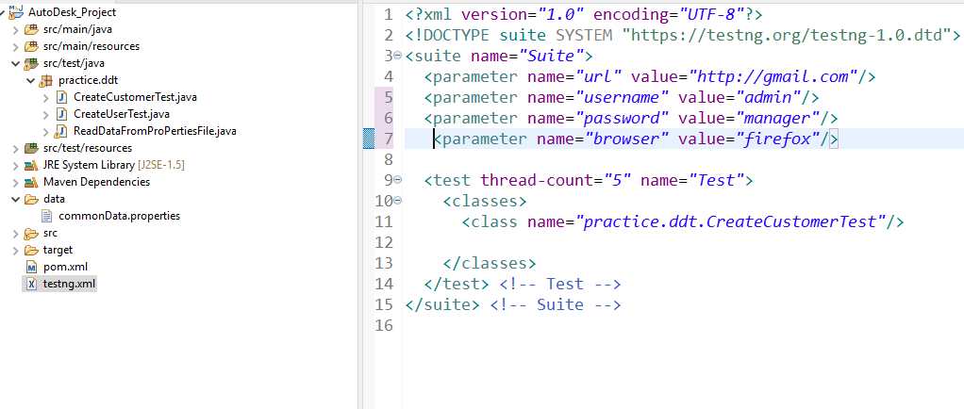

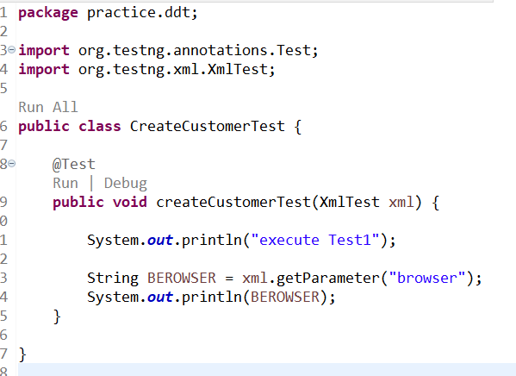

1. **How To Read Data From JSON File**

**package** DDT.practice;

**import** java.io.FileNotFoundException;

**import** java.io.FileReader;

**import** java.util.HashMap;

**import** org.json.simple.parser.JSONParser;

**import** org.testng.annotations.Test;

/**

* This class for reading data from JSON File

* **@author** SOUMYASANTA SAHOO

*

*/

**public** **class** ReadTheDataFromJSONFileTest {

@Test

**public** **void** readTheDataFromJsonFile() **throws** Throwable

{

//Step=1 convert the JSON File into Json Object

FileReader fr=**new** FileReader("./Data/commonData.json");

//Step=2 convert JSON Object into Java Object

JSONParser jp=**new** JSONParser();

Object jObj = jp.parse(fr);

//Step=3 Read the data using HashMap

HashMap obj = (HashMap)jObj;

Object value = obj.get("url");

System.***out***.println(value);

}

}